**Crypto Bareksa - Mobile Apps - Phase 1**

| **Document Version** | V.1.0.0 |
| --- | --- |
| **Project Name** | **Crypto Bareksa Consumer Mobile App**  **> iOS**  **> Android** |
| **PM** | [fury oktria](mailto:furyoktriaputra@gmail.com) |
| **Designer** | N/A |
| **Engineering Manager/ Tech Lead** | @fury_engineering_manager |
| **Engineering Squad** | @fury_front_end_engineer  @fury_back_end_engineer  @fury_mobileengineer_iOS  @fury_mobileengineer_android |
| **Date Created** | Sep 8, 2024 |

**Background**

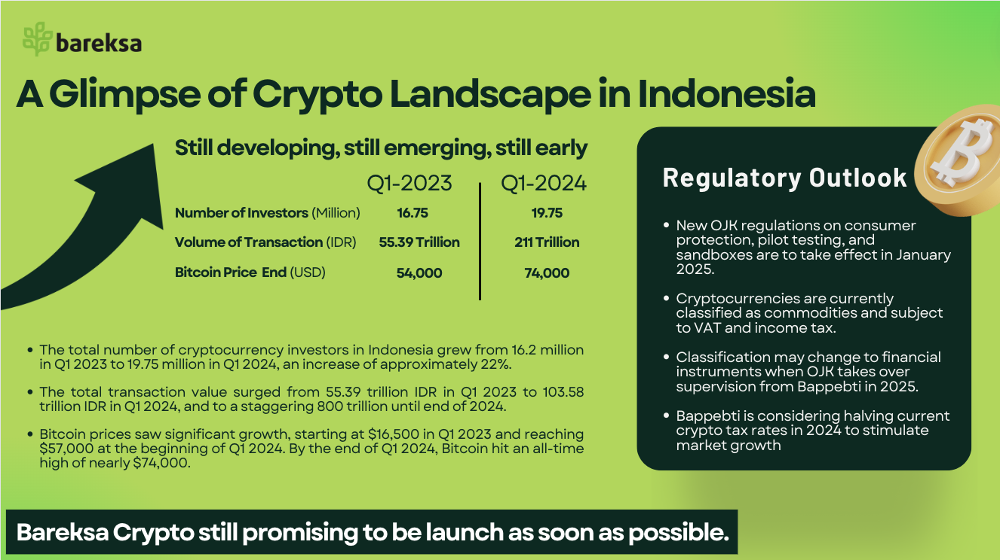

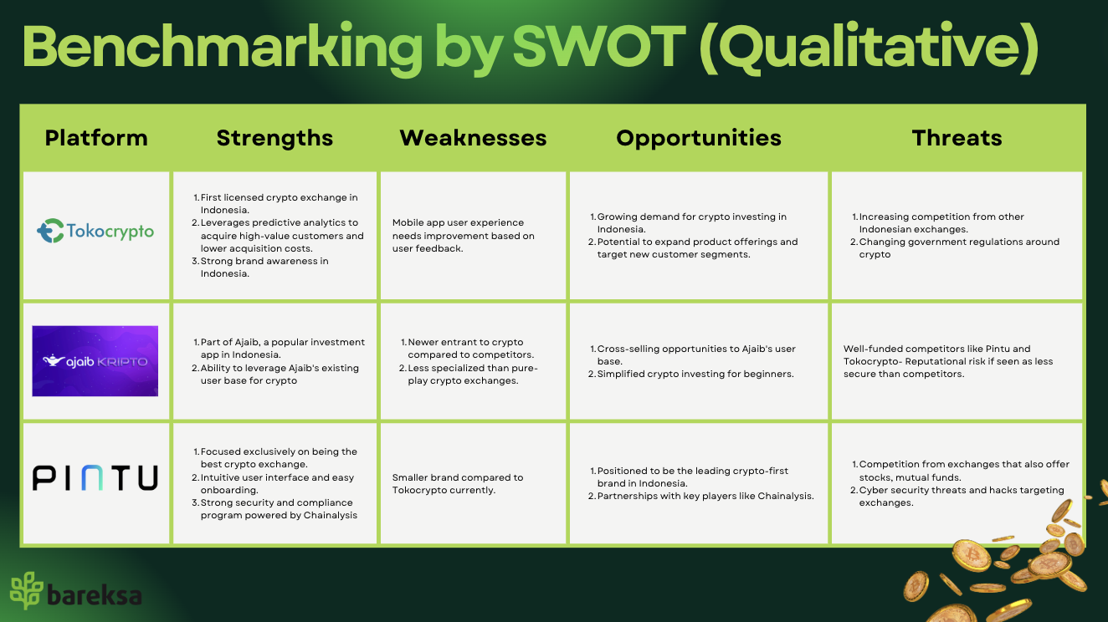

**User**

| **User Segment** | **Description** | **Needs and Preferences** |
| --- | --- | --- |
| Retail Investors (P0) | Individual investors looking to diversify their portfolio with cryptocurrencies, especially those coming from Bareksa retailers. | 1. User-friendly interface. 2. Educational resources. 3. Low fees and minimum investments. 4. Secure wallet and storage options. |
| Traders (P2) | Active traders seeking to profit from cryptocurrency price movements | 1. Advanced trading features (e.g., margin trading, stop-loss orders). 2. Real-time market data and charts. 3. Low trading fees and high liquidity. 4. API access for automated trading. |
| Institutional Investors (P4) | Financial institutions, hedge funds, and investment firms allocating capital to cryptocurrencies. | 1. Institutional-grade security and compliance. 2. High liquidity and OTC (Over-the-Counter) trading. 3. Customized reporting and account management. 4. Dedicated customer support |
| Beginners (P1) | New investors seeking an easy entry point into cryptocurrency investing. | 1. Simple and intuitive user interface. 2. Educational content and guides. 3. Demo accounts and low minimum investments. 4. Customer support and help center. |

**Goal**

| **Category** | **Deliverables** | **Metrics** |
| --- | --- | --- |
| iOS mobile app | > Develop a native iOS app compatible with iPhones running iOS 14 or later.  > Ensure the app adheres to Apple's App Store guidelines and passes the review process. | > App Store rating: Aim for a 4.5-star rating or higher.  > App stability: Ensure a crash-free rate of 99.5% or higher.  > User acquisition: Achieve 10,000 app downloads within the first 3 months of launch. |
| Android mobile app | > Develop a native Android app compatible with devices running Android 7.0 (Nougat) or later.  > Ensure the app adheres to Google Play Store guidelines and passes the review process. | > Google Play Store rating: Aim for a 4.5-star rating or higher.  > App stability: Ensure a crash-free rate of 99.5% or higher.  > User acquisition: Achieve 15,000 app downloads within the first 3 months of launch. |

**Scope - Registration**

| **Feature Name** | **User Story** | **Acceptance Criteria** |
| --- | --- | --- |
| User Registration | As a new user, I want to create an account so that I can access the Bareksa Crypto app features. | **Scenario: Successful user registration**  > Given I am on the registration page  > When I enter valid registration details  > And I submit the registration form  > Then I should see a success message  > And I should be redirected to the app home screen  **Scenario: Email address already in use**  > Given I am on the registration page  > When I enter an email that is already registered  > And I submit the registration form  > Then I should see an "email already in use" error message  **Scenario: Weak password**  Given I am on the registration page  When I enter a weak password  And I submit the registration form  Then I should see a "password too weak" error message |
| User Login | As a registered user, I want to log in to my account so that I can access my wallet and perform transactions. | gherkin<br>Feature: User Login<br><br>Scenario: Successful login<br>Given I am on the login page<br>When I enter my registered email address<br>And I enter my correct password<br>And I tap on the "Login" button<br>Then I should be redirected to the app home screen<br><br>Scenario: Invalid email address<br>Given I am on the login page<br>When I enter an unregistered email address<br>And I enter a password<br>And I tap on the "Login" button<br>Then I should see an error message indicating that the email address is invalid<br><br>Scenario: Incorrect password<br>Given I am on the login page<br>When I enter my registered email address<br>And I enter an incorrect password<br>And I tap on the "Login" button<br>Then I should see an error message indicating that the password is incorrect<br> |
| Forgot Password | As a user, I want to reset my password if I forget it so that I can regain access to my account. | gherkin<br>Feature: Forgot Password<br><br>Scenario: Successful password reset<br>Given I am on the login page<br>And I tap on the "Forgot Password" link<br>When I enter my registered email address<br>And I tap on the "Reset Password" button<br>Then I should see a success message indicating that a password reset link has been sent to my email<br>When I open the password reset link from my email<br>And I enter a new strong password<br>And I confirm the new password<br>And I tap on the "Update Password" button<br>Then I should see a success message indicating that my password has been reset<br>And I should be redirected to the login page<br><br>Scenario: Unregistered email address<br>Given I am on the login page<br>And I tap on the "Forgot Password" link<br>When I enter an unregistered email address<br>And I tap on the "Reset Password" button<br>Then I should see an error message indicating that the email address is not associated with any account<br> |
| User Profile Setup | As a new user, I want to set up my profile so that I can provide necessary information and personalize my account. | gherkin<br>Feature: User Profile Setup<br><br>Scenario: Successful profile setup<br>Given I have successfully registered for an account<br>And I am redirected to the profile setup page<br>When I enter my full name<br>And I enter my phone number<br>And I select my country of residence<br>And I tap on the "Save" button<br>Then I should see a success message indicating that my profile has been updated<br>And I should be redirected to the app home screen<br><br>Scenario: Incomplete profile information<br>Given I have successfully registered for an account<br>And I am redirected to the profile setup page<br>When I enter my full name<br>And I leave the phone number field blank<br>And I tap on the "Save" button<br>Then I should see an error message indicating that the phone number field is required<br>And I should remain on the profile setup page<br> |

**Project: SEO Implementation - Phase 1**

| **Feature** | **User Story** | **User Acceptance Criteria** |
| --- | --- | --- |
|  |  |  |
|  |  |  |
|  |  |  |
|  |  |  |
|  |  |  |

**Implementation**

1. We can set a design experiment with timeline 4 months with well-distributed traffic for 4 different usecases:  
   A. Revamp web-pages (mobile and desktop) yes, SEO Implementation (No)  
   B. Revamp web-pages (mobile and desktop) yes, SEO Implementation (Yes)  
   **C. Revamp web-pages (mobile and desktop) No, SEO Implementation (No) -> existing**D. Revamp web-pages (mobile and desktop) No, SEO Implementation (Yes)
2. Collaborate with Data Analyst and revisit after 4 months
3. Gather the data with Google Console (Google Analytics).
4. The winner of traction after 4 months (compared each others) will be set as the new approach.